Honey Creek Community School
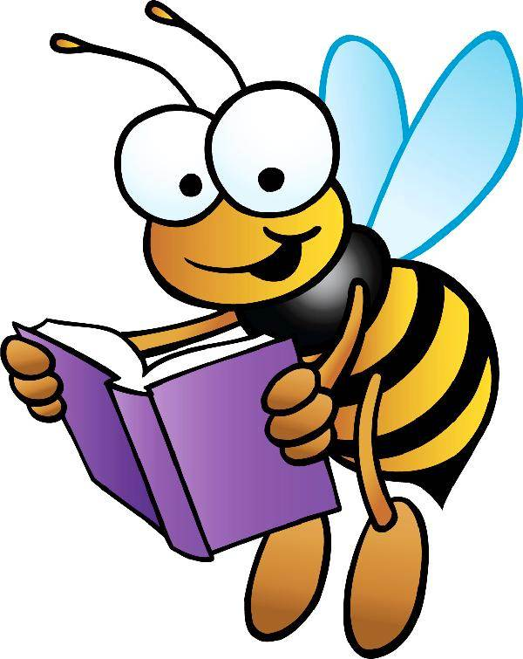
Reading BINGO

Have fun, try something different and find new ways of discovering good books!
Put an X through each completed square. Try to get a BINGO by completing a full row in any direction.

Little Kid Book | Ask a librarian for a reading suggestion | Read about a favorite sport or hobby | Talk about a book with your family | Read a magazine
Read some Fiction | Do a word search or crossword puzzle | Find a book you think you’d like on Novelist  mel.org/az.php | Boys: Read about a girl  Girls: Read about a boy | Read with a pet
Read to someone else | Explore Non-  fiction | FREE | Ask a friend  for a book suggestion | Read about someone from a different background
Read about another Country | Tell a friend about a good book | Listen to an audio  book | Read a poem  Try poets.org/poems-kids or  poets.org/poems-teens | Pick an award-winning book  Try ALA Youth Media, APALA, or Cybils
Watch a book trailer or read-aloud on YouTube | Read a Michigan author | Read to yourself | Check out a graphic novel | Read  a map
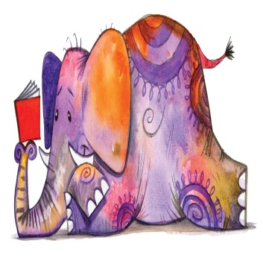

Name

Teacher/Class
